Linux assignment

1.Write a shell program to find if the inputted number is even or odd.

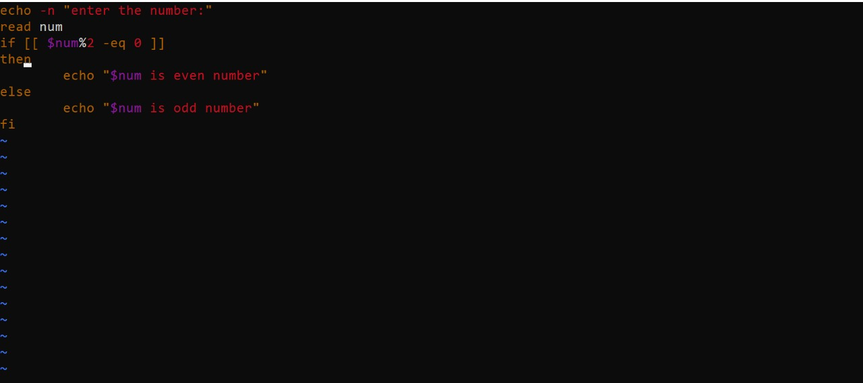

2.Write a shell program to compute the bill amount by applying below rules a. if the purchase amount is less than 1000, then the applicable tax is 5% and the discount is 10% b. if the amount is 1000 or greater then the tax applicable is 7% and the discount is 20%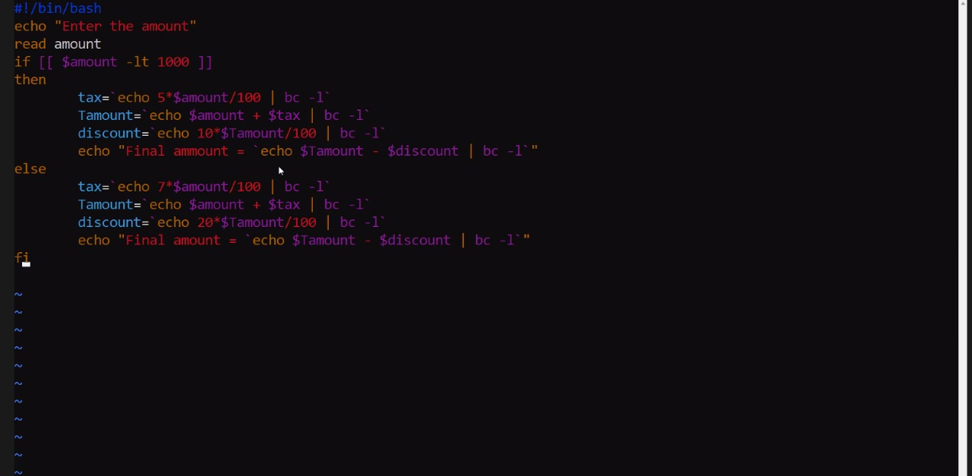

3.Write a shell program to generate a Fibonacci series

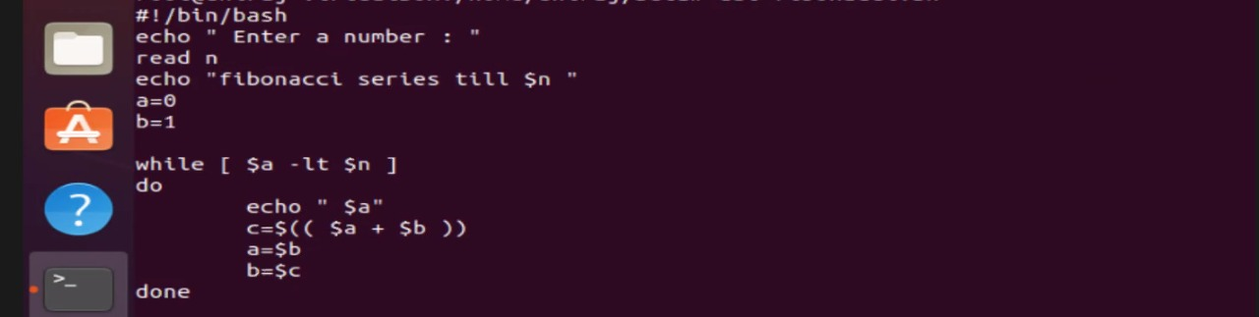 .

4.Write a shell program to find the greatest number of given 3 numbers

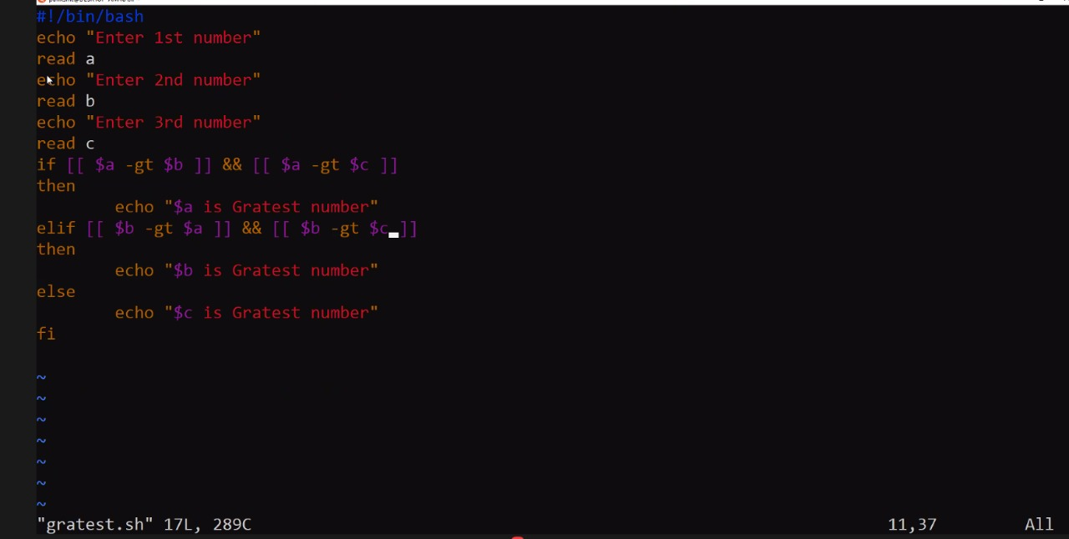

5 .Build a calculator with basic operations add, subtract, multiply and divide using shell program switch statement.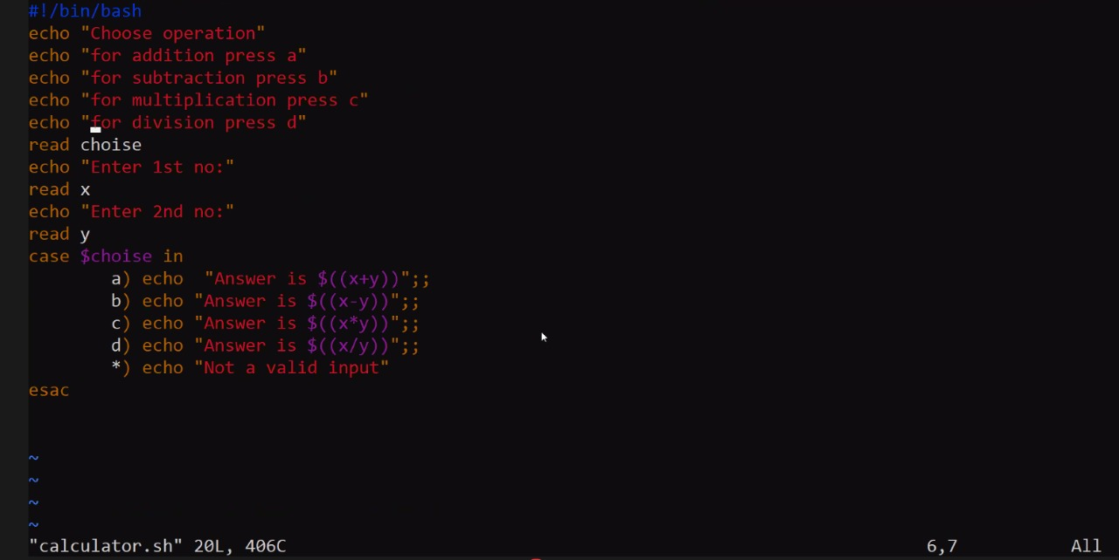

6.. Write a shell program to find if the inputted year is leap or not 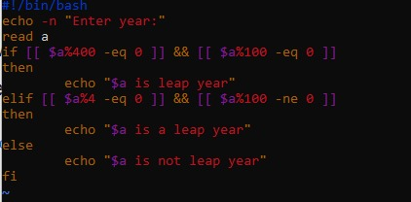

7. Write a shell program to convert a decimal number to binary equivalent.

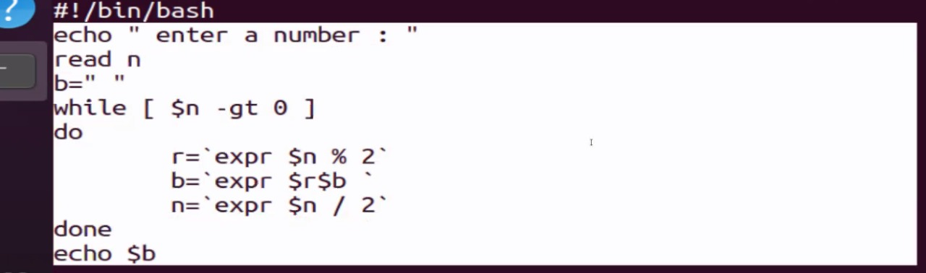

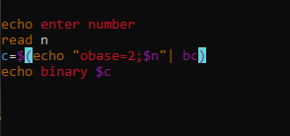

8. Write a script to swap 2 numbers using an intermediate variable.

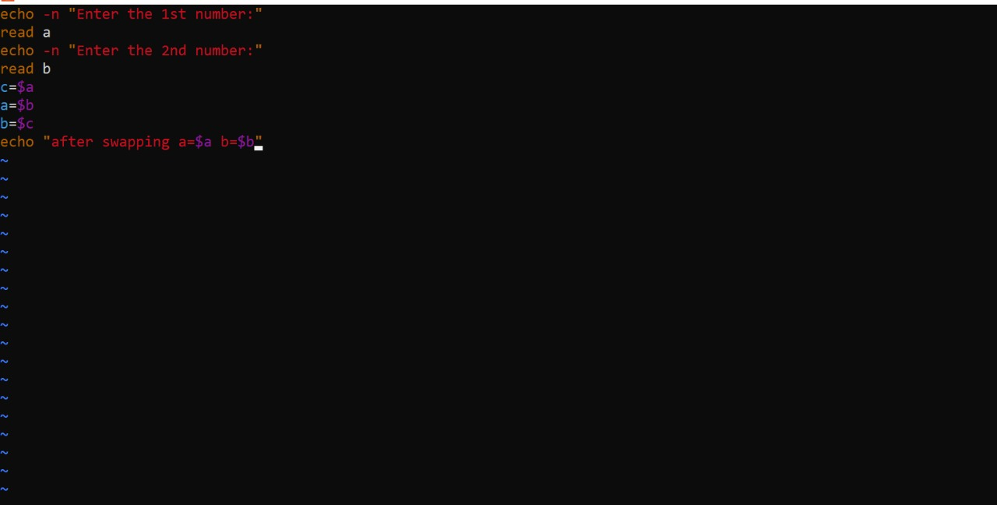

9. print multiplication table of integer using while loop.

Example: 2 x 1 =2

2 x 2 = 4

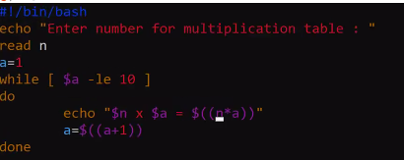

10. Write a script to read the number of rows to be displayed in the pattern and print following pattern using for loop:

1

23

456

